Student Feedback Sentiment Scoring

Author: Radhasahithi Challa
1. Problem Statement
Develop a Python program to analyse multiple student feedback sentences using a predefined list of positive and negative keywords. The program counts positive and negative indicators in each sentence, calculates a sentiment score, and classifies the feedback as Positive, Negative, or Neutral based on predefined thresholds.
2. Objectives
- Accept feedback sentences from multiple students.
- Define lists of positive and negative keywords.
- Count positive and negative keywords in each feedback sentence.
- Calculate a sentiment score for every sentence.
- Classify feedback using predefined thresholds.
- Display a report containing the feedback, keyword counts, score, and sentiment.
3. Assumptions
- The program accepts multiple feedback sentences.
- Positive keywords include good, excellent, helpful, interesting, and clear.
- Negative keywords include bad, boring, difficult, poor, and confusing.
- Feedback is converted to lowercase before analysis.
- The sentiment score is calculated as:
- If the score is greater than 0, feedback is classified as Positive.
- If the score is less than 0, feedback is classified as Negative.
- If the score equals 0, feedback is classified as Neutral.
- This is a simple keyword-based system; it does not understand context, sarcasm, or negation.
4. Algorithm
- Start the program.
- Define positive and negative keyword lists.
- Input the number of feedback sentences.
- Read each feedback sentence.
- Convert the sentence to lowercase.
- Initialize positive and negative counters to zero.
- Check each word against the positive keyword list and count matches.
- Check each word against the negative keyword list and count matches.
- Calculate the sentiment score by subtracting the negative count from the positive count.
- Classify the feedback based on the score.
- Display the feedback, positive count, negative count, score, and classification.
- Repeat for all feedback sentences.
- Stop.
5. Flowchart
START
Define positive and negative keyword lists
Input number of feedback sentences and read a sentence
Convert to lowercase and count positive and negative keywords
Calculate score = positive count − negative count
Score greater than 0? Positive
Score less than 0? Negative
Score equals 0? Neutral
Display sentiment report and process remaining feedback
STOP

6. Pseudocode
BEGIN

positive_keywords = ["good", "excellent", "helpful",
"interesting", "clear"]
negative_keywords = ["bad", "boring", "difficult",
"poor", "confusing"]
INPUT number_of_feedback
FOR each feedback sentence:
INPUT feedback
CONVERT feedback to lowercase
SPLIT feedback into words
positive_count = 0
negative_count = 0
FOR each word:
IF word is in positive_keywords:
positive_count = positive_count + 1
IF word is in negative_keywords:
negative_count = negative_count + 1
score = positive_count - negative_count
IF score > 0:
sentiment = "Positive"
ELSE IF score < 0:
sentiment = "Negative"
ELSE:
sentiment = "Neutral"
DISPLAY feedback
DISPLAY positive_count
DISPLAY negative_count
DISPLAY score
DISPLAY sentiment

END FOR
END

- Line-by-Line Explanation

Code / statement | Explanation
positive_keywords = [...] | Defines words indicating positive feedback.
negative_keywords = [...] | Defines words indicating negative feedback.
n = int(input(...)) | Reads the number of feedback sentences.
if n <= 0: | Checks whether the entered number is valid.
for i in range(1, n + 1): | Repeats the analysis for each sentence.
input(...).lower() | Reads feedback and converts it to lowercase.
words = feedback.split() | Splits the sentence into individual words.
sum(word.strip(...) in positive_keywords for word in words) | Counts words that match the positive list after removing common punctuation.
sum(word.strip(...) in negative_keywords for word in words) | Counts words that match the negative list.
score = positive_count - negative_count | Calculates the sentiment score.
if score > 0: | Identifies positive feedback.
elif score < 0: | Identifies negative feedback.
else: | Identifies neutral feedback when the score is zero.
print(...) | Displays the feedback analysis report.
9. Test Cases
Test | Input feedback | Positive count | Negative count | Score | Expected classification
1 | The class was good and helpful | 2 | 0 | 2 | Positive
2 | The lecture was boring and confusing | 0 | 2 | -2 | Negative
3 | The class was informative | 0 | 0 | 0 | Neutral
4 | Excellent teaching but difficult topic | 1 | 1 | 0 | Neutral
5 | Good, clear and interesting lesson | 3 | 0 | 3 | Positive
6 | Poor and bad explanation | 0 | 2 | -2 | Negative
10. Sample Output
Enter number of feedback sentences: 3
Enter feedback 1: The class was good and helpful
--- Feedback Sentiment Report ---
Feedback: the class was good and helpful
Positive Indicators: 2
Negative Indicators: 0
Sentiment Score: 2
Classification: Positive
Enter feedback 2: The lecture was boring and confusing
--- Feedback Sentiment Report ---
Feedback: the lecture was boring and confusing
Positive Indicators: 0
Negative Indicators: 2
Sentiment Score: -2
Classification: Negative

Enter feedback 3: The class was informative
--- Feedback Sentiment Report ---
Feedback: the class was informative
Positive Indicators: 0
Negative Indicators: 0
Sentiment Score: 0
Classification: Neutral

My output

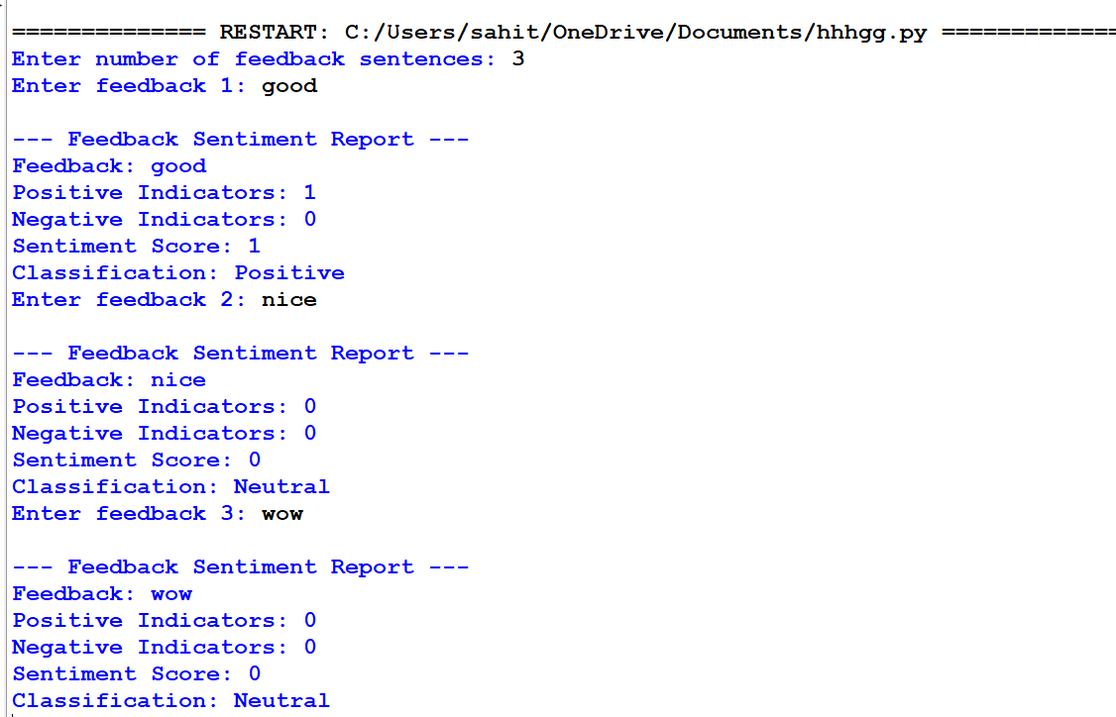

11. Conclusion
The Student Feedback Sentiment Scoring program analyses student comments using predefined positive and negative keywords. It calculates a sentiment score and classifies each sentence as positive, negative, or neutral. This approach is simple to implement in Python and can help summarise student opinions about teaching and learning. However, its accuracy depends on the supplied keyword list and it may not recognise negation, such as “not good.”

